**Logging:**

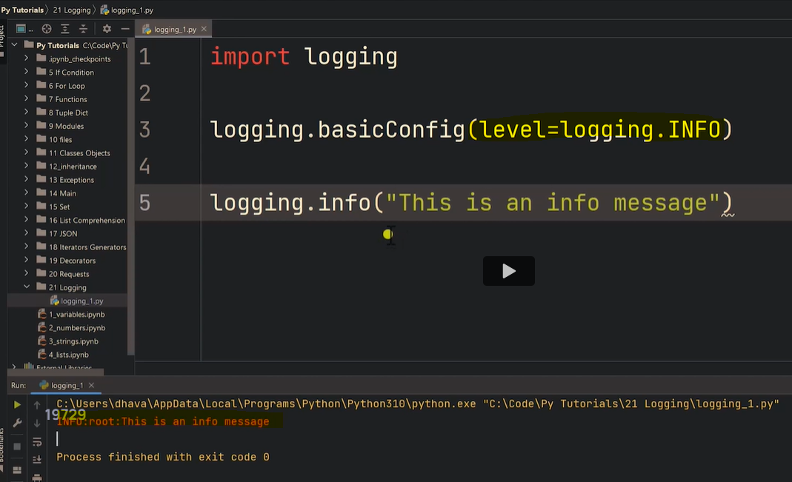

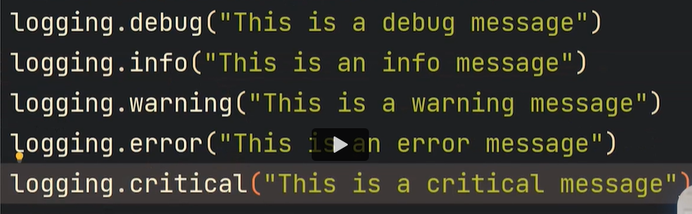

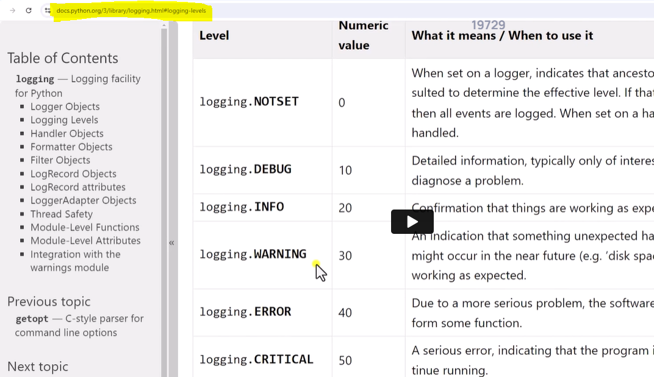

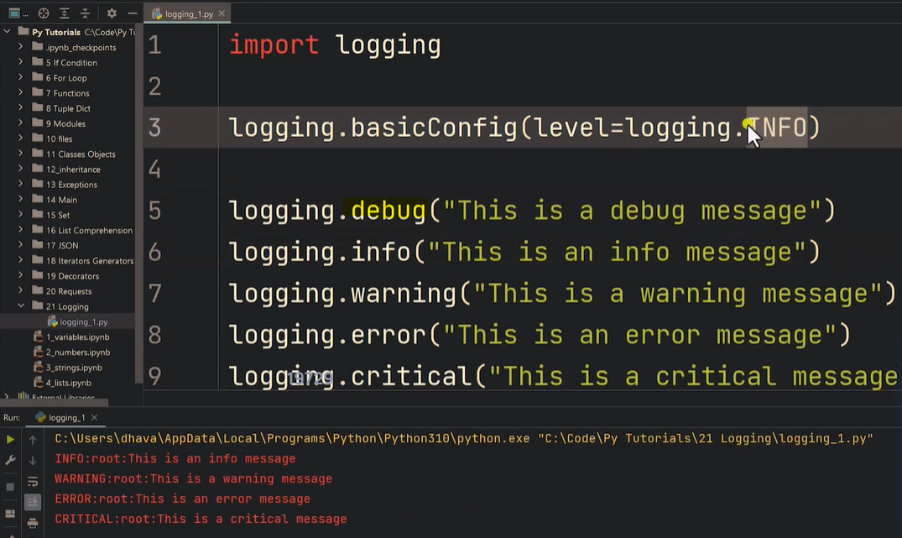

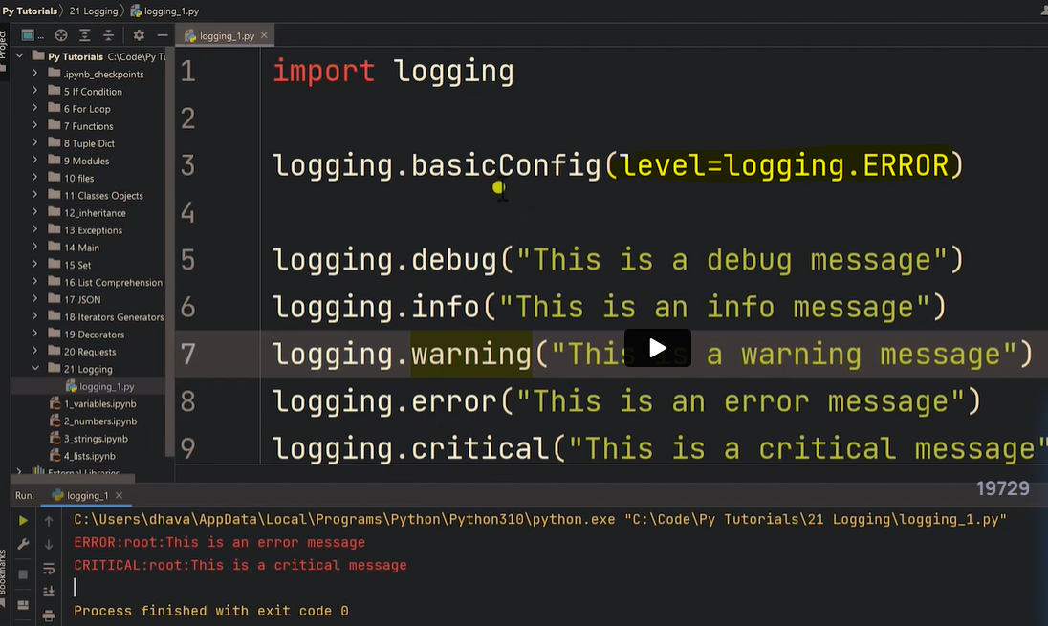

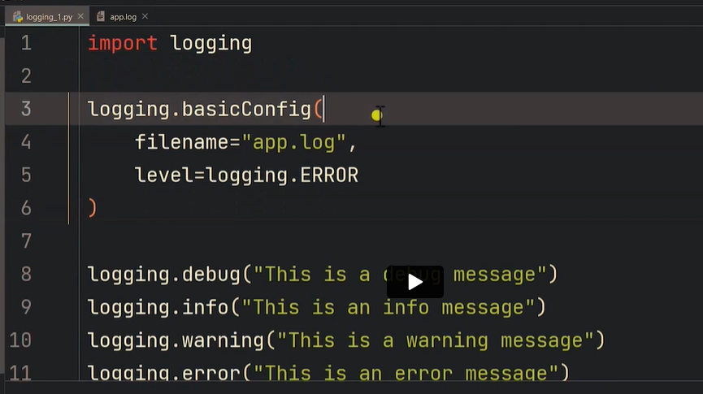

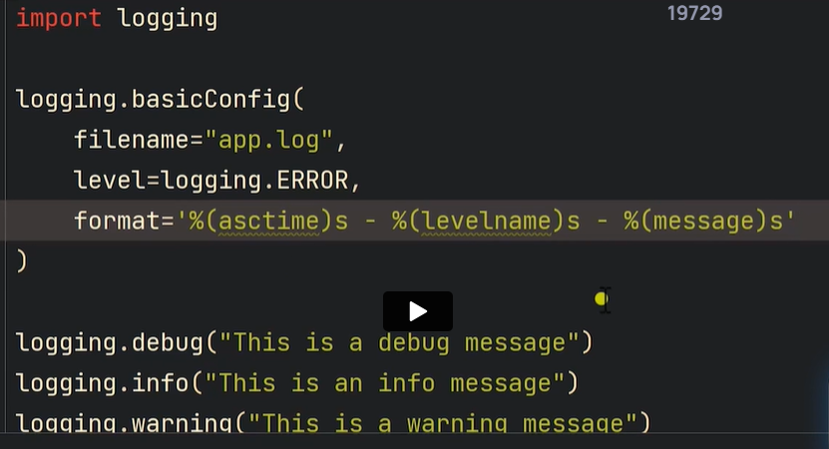

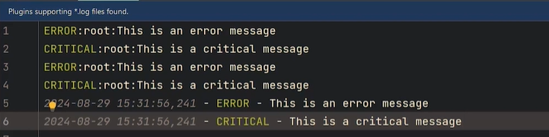

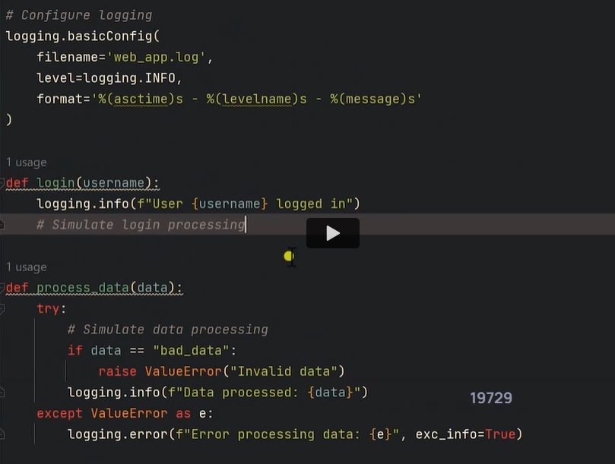

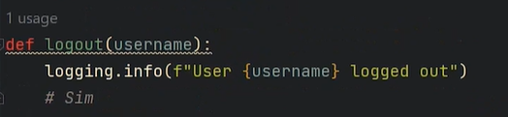

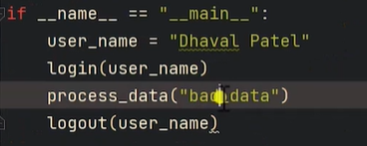

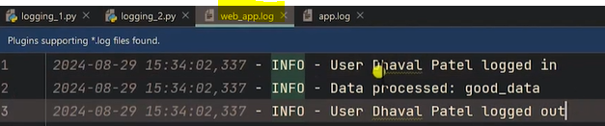

Run with exc_info as True

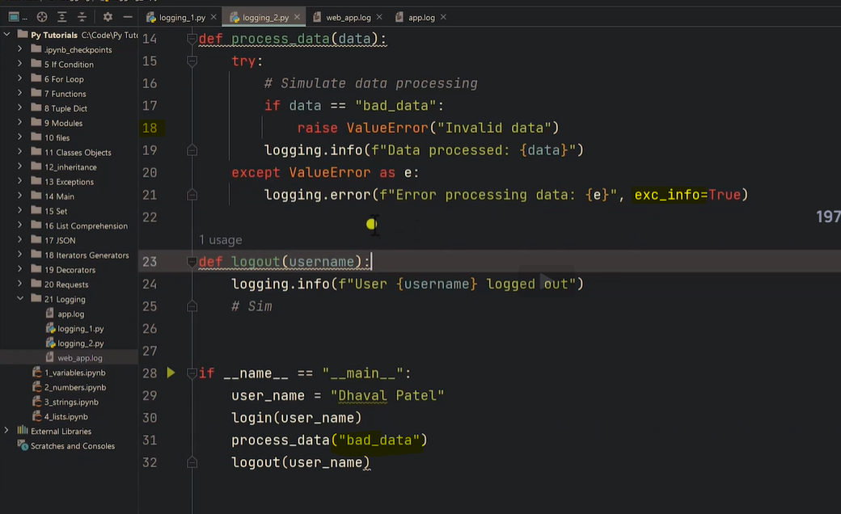

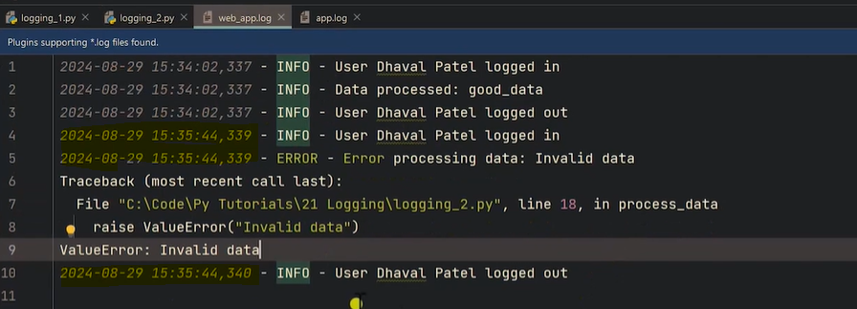

**Run with exc_info as False**

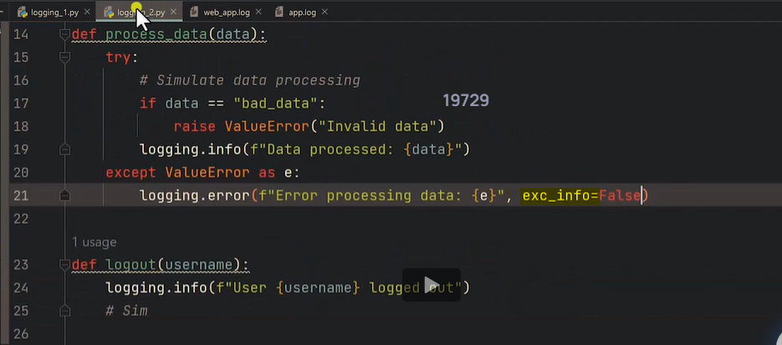

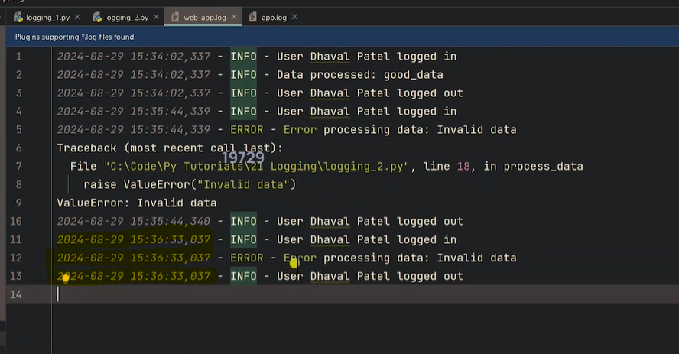

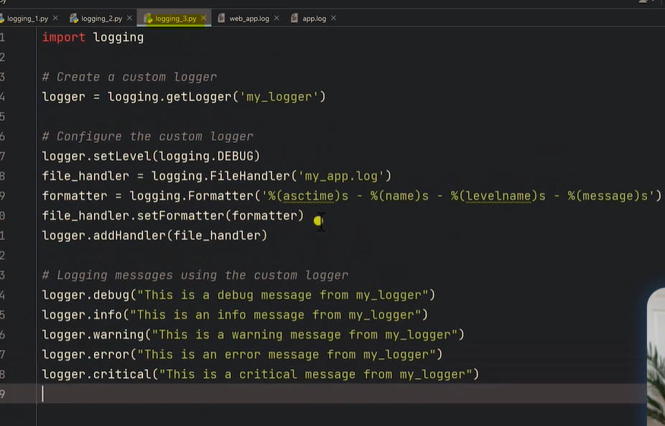

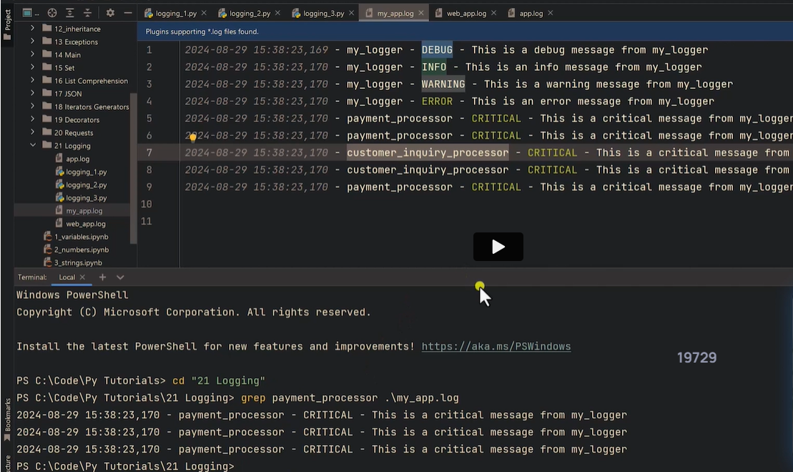

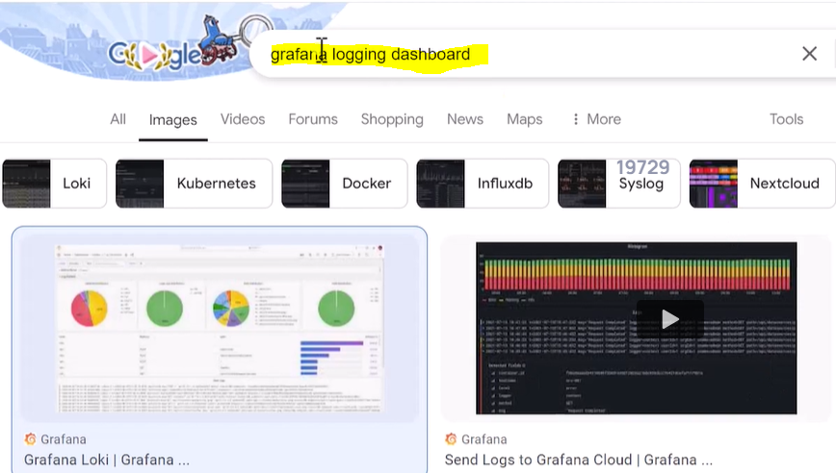

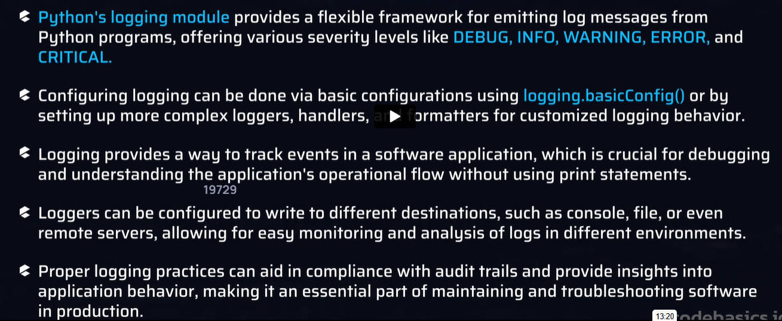

Automated Testing with Pytest

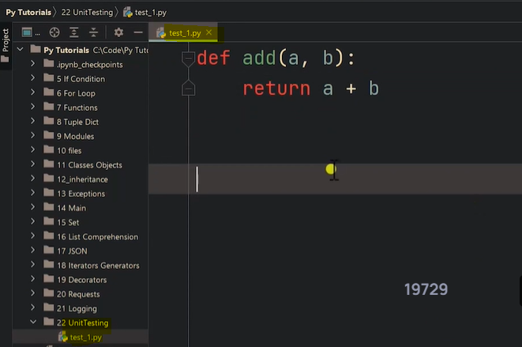

For unit testing, function name should prefix with test_

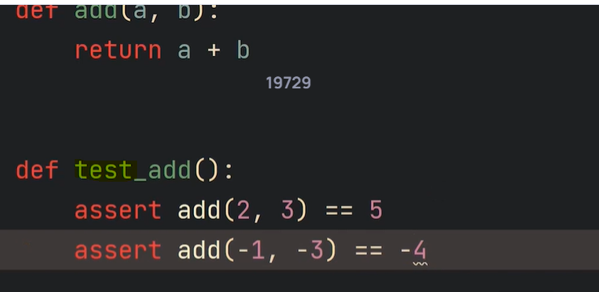

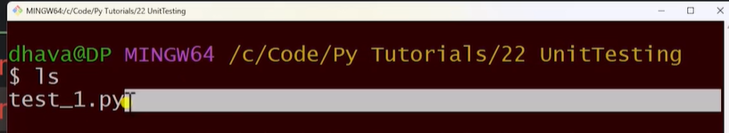

pip install pytest

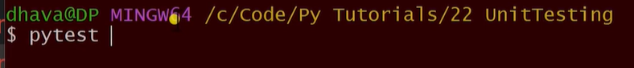

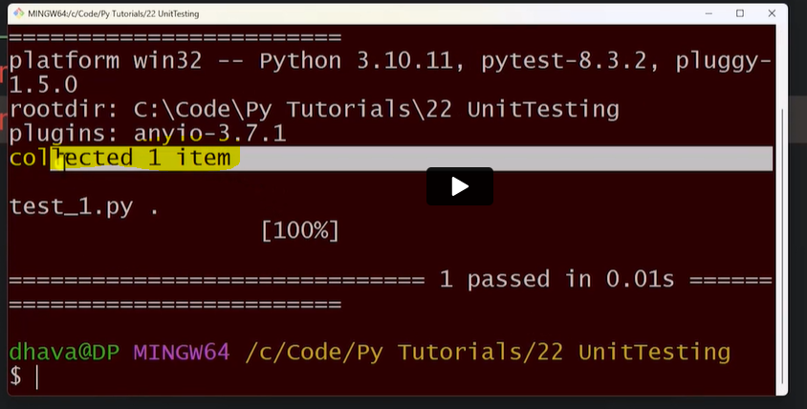

Pytest -v

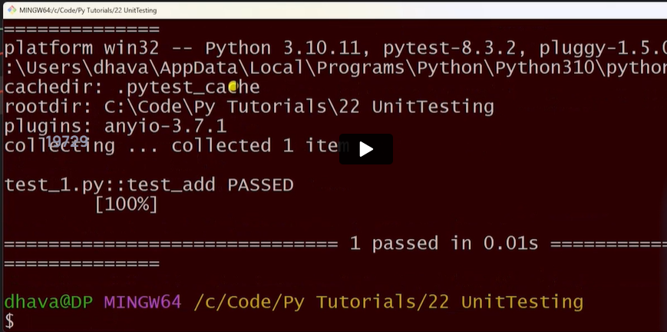

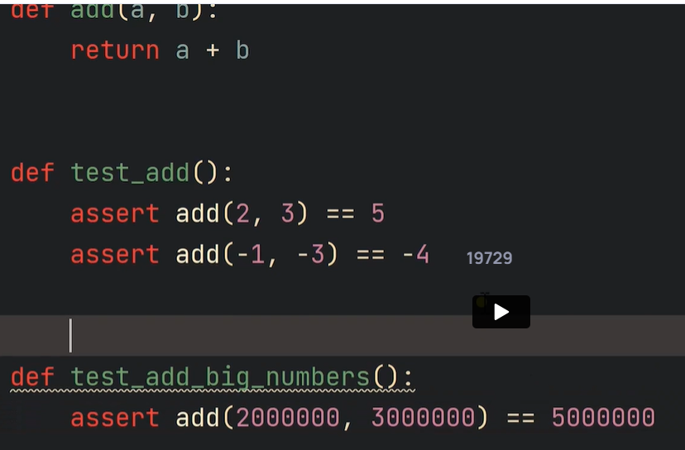

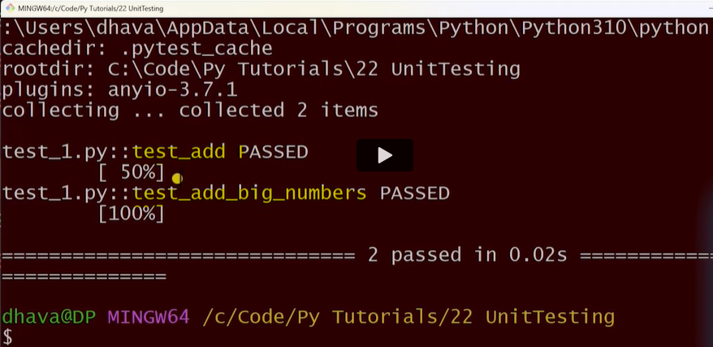

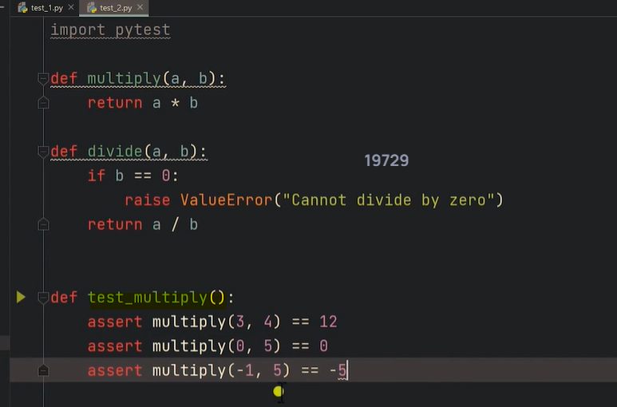

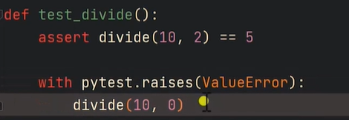

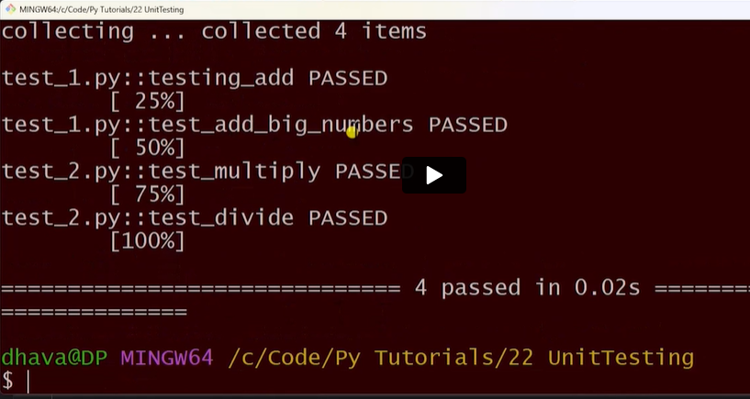

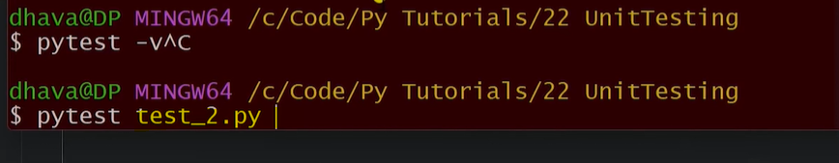

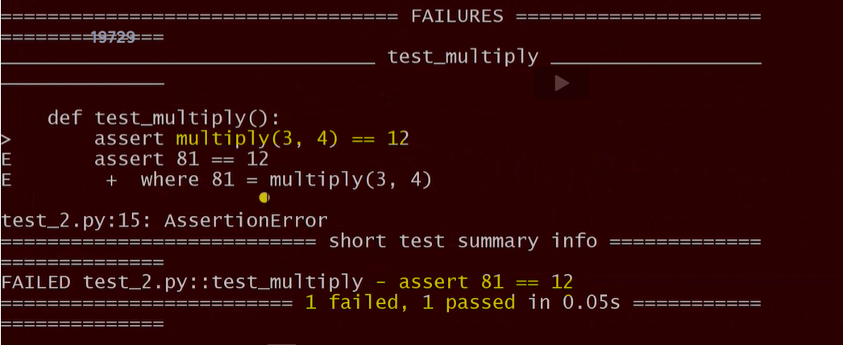

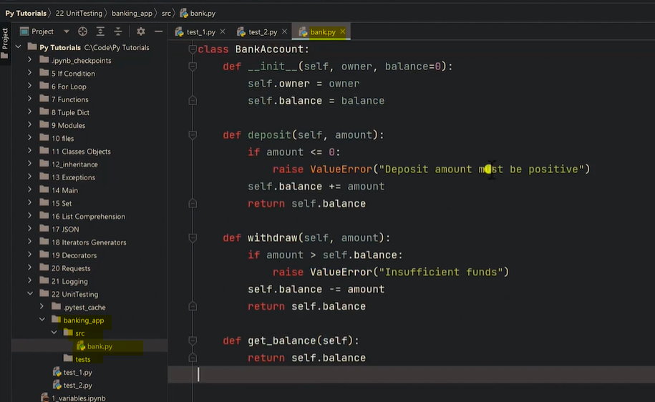

Banking app can be considered as package

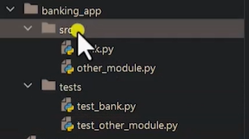

test1_bank.py

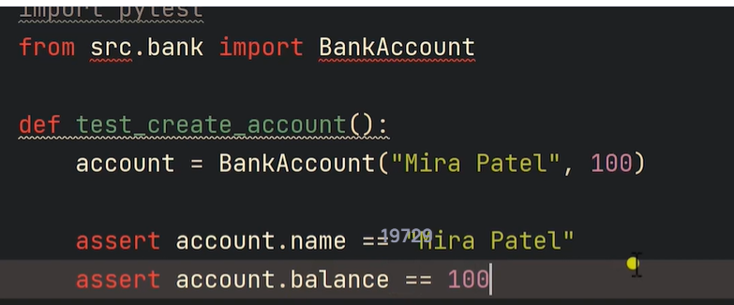

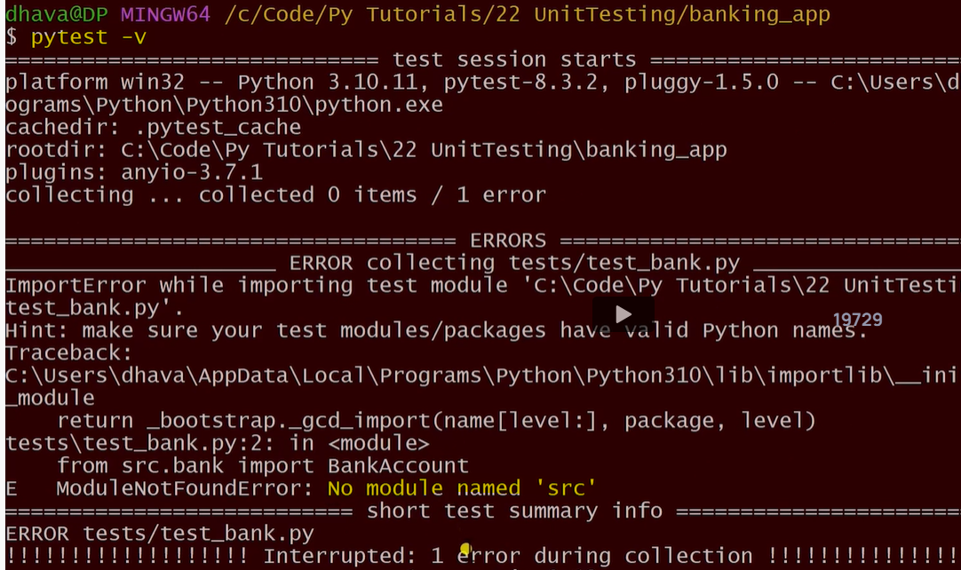

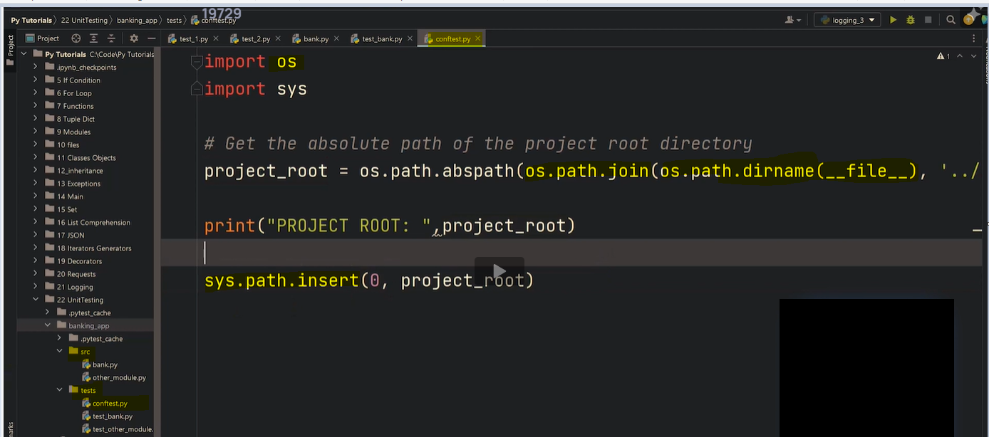

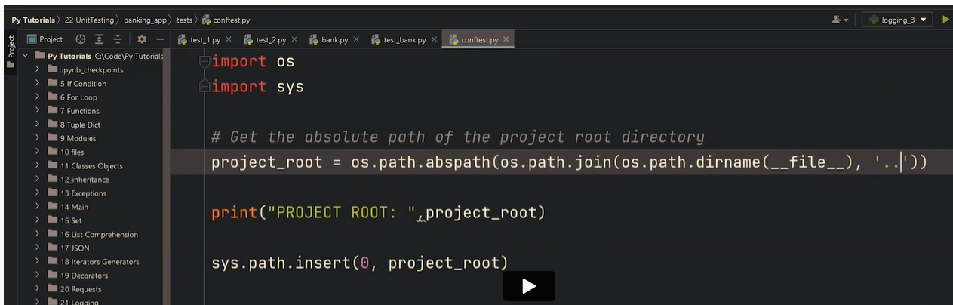

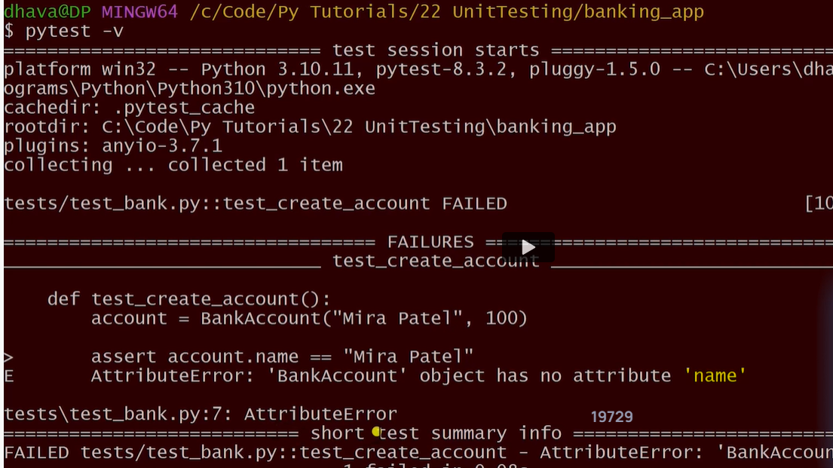

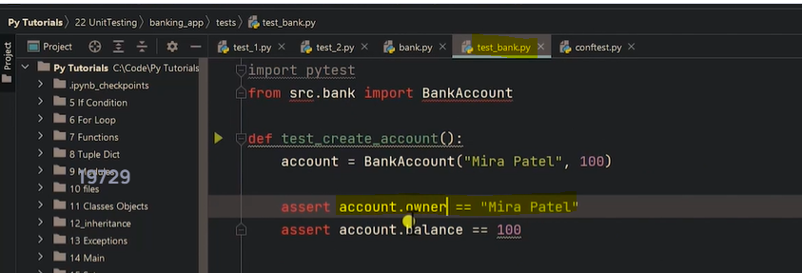

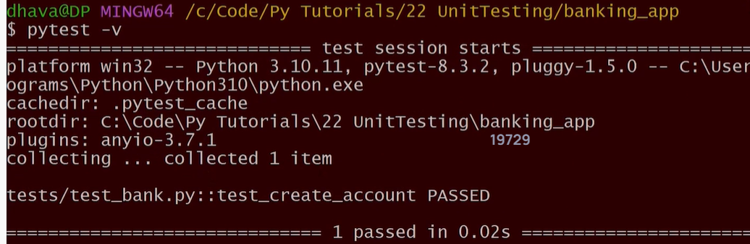

Multiple test for different functions

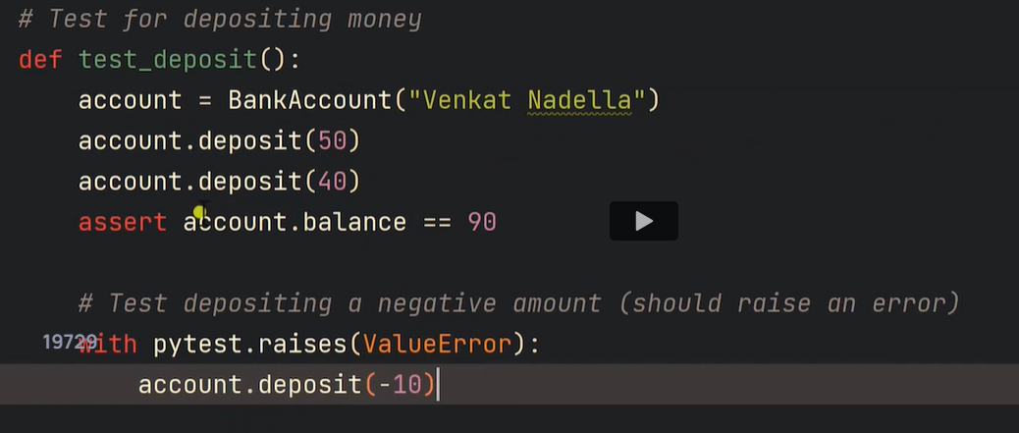

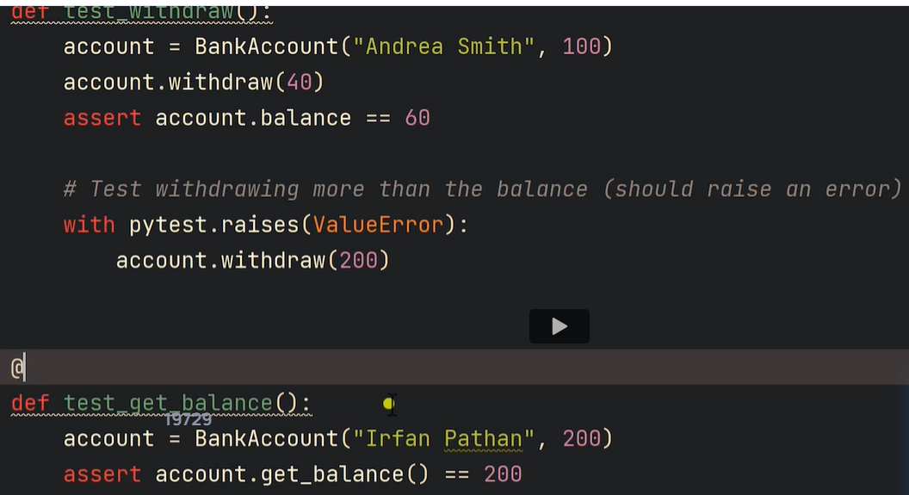

Skipping a test when running pytest

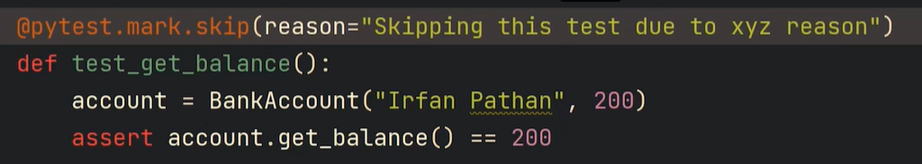

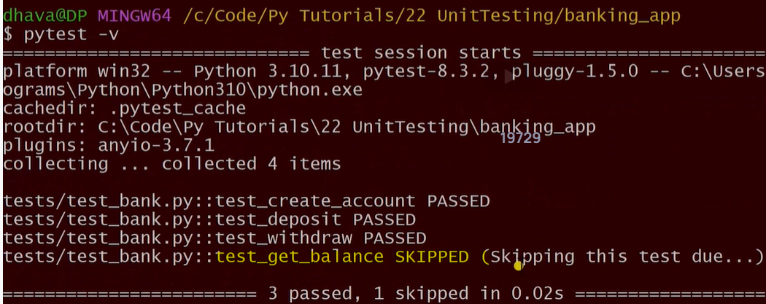

**Example**

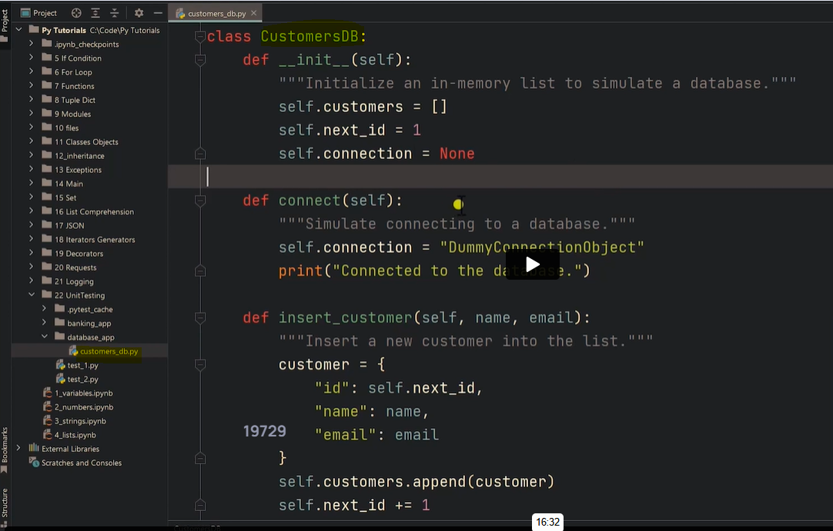

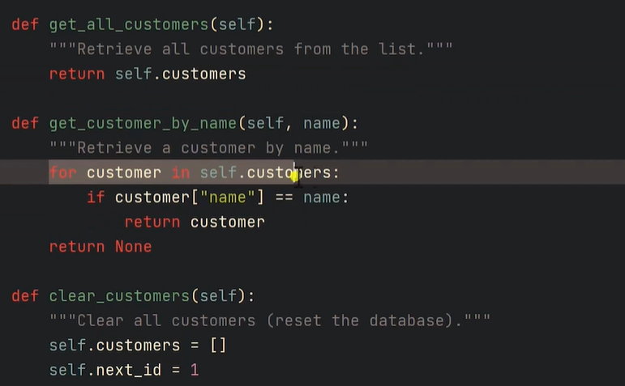

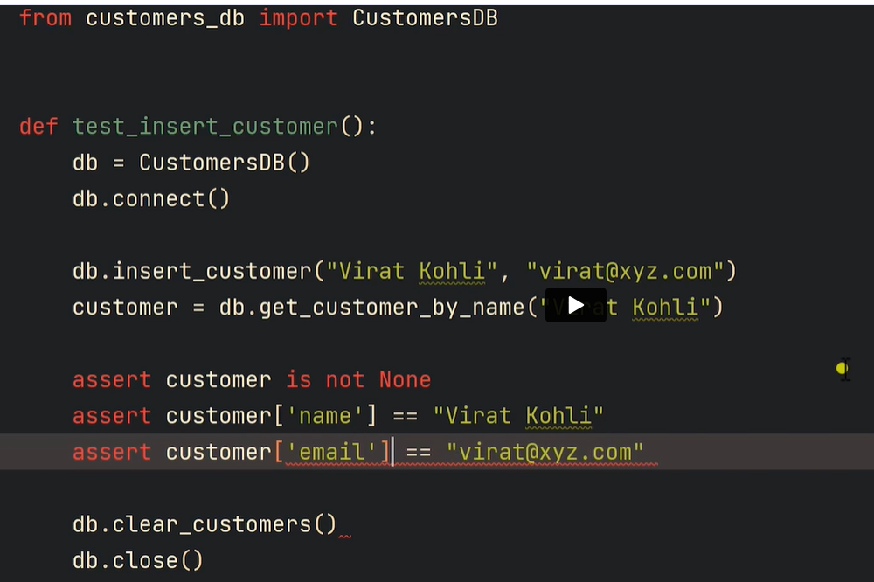

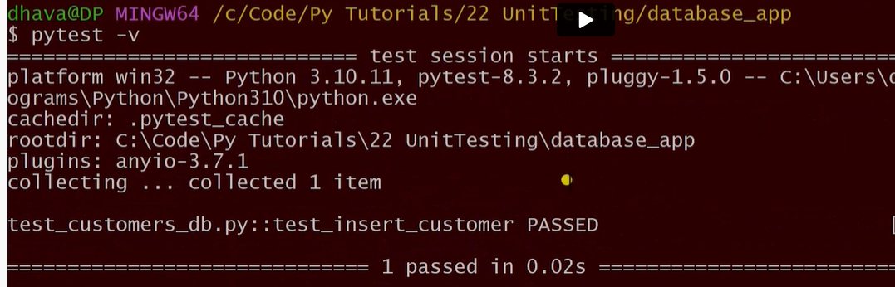

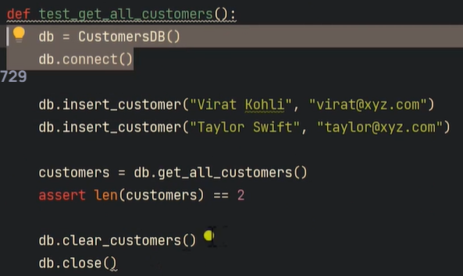

**Pytest fixture**

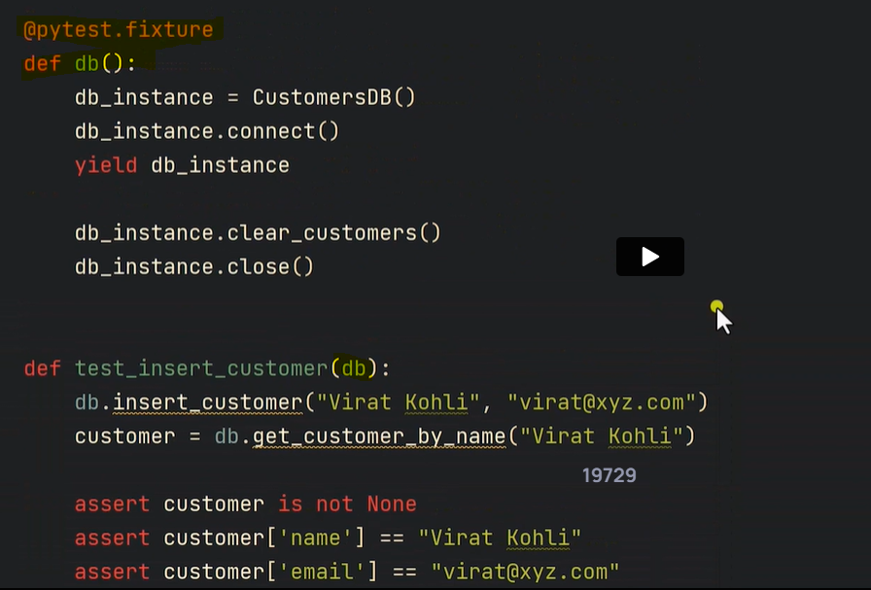

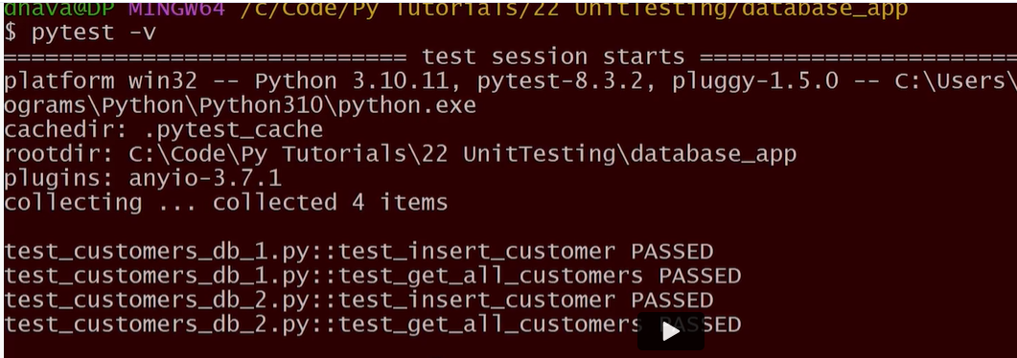

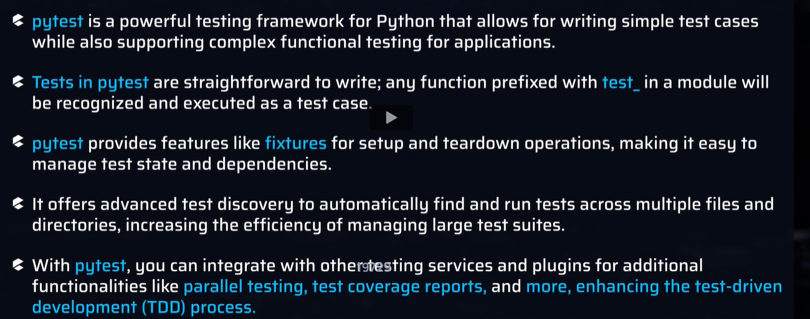

**Working with MySQL in python**

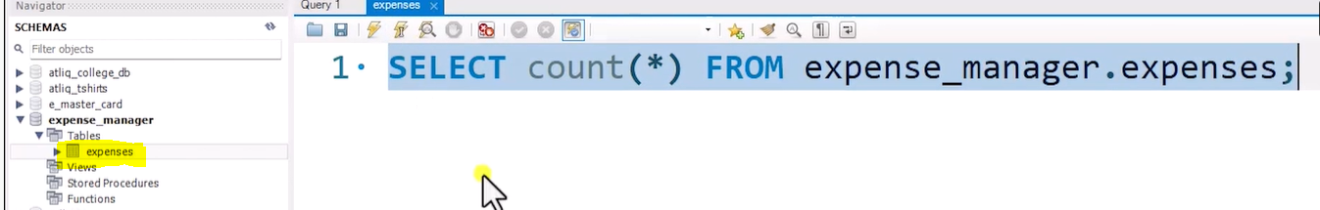



import mysql.connector  
  
connection = mysql.connector.connect(  
 host='localhost',  
 user='root',  
 password='root',  
 database='expense_manager'  
)  
  
if connection.is_connected():  
 print("connection successful")  
else:  
 print("connection not successful")  
  
cursor = connection.cursor()  
cursor.execute("SELECT * FROM expense_manager.expenses")  
expenses = cursor.fetchall()  
  
for expense in expenses:  
 print(expense)  
  
connection.close()

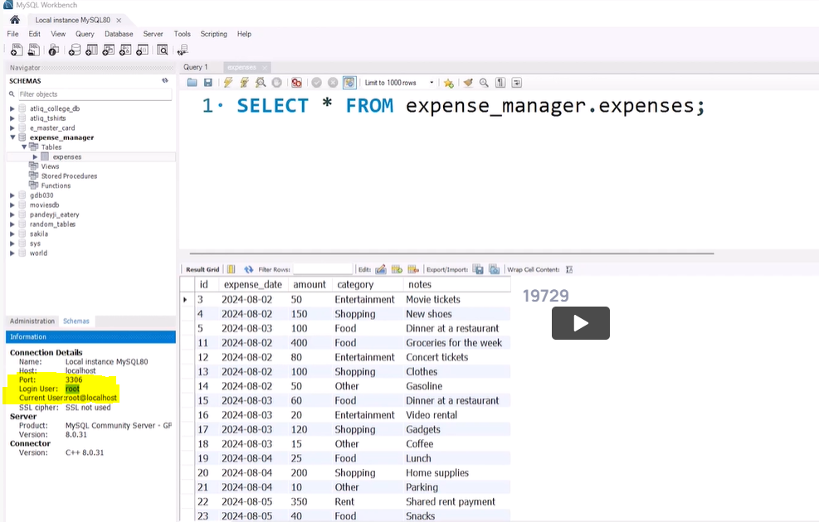

Retrieval as tuple

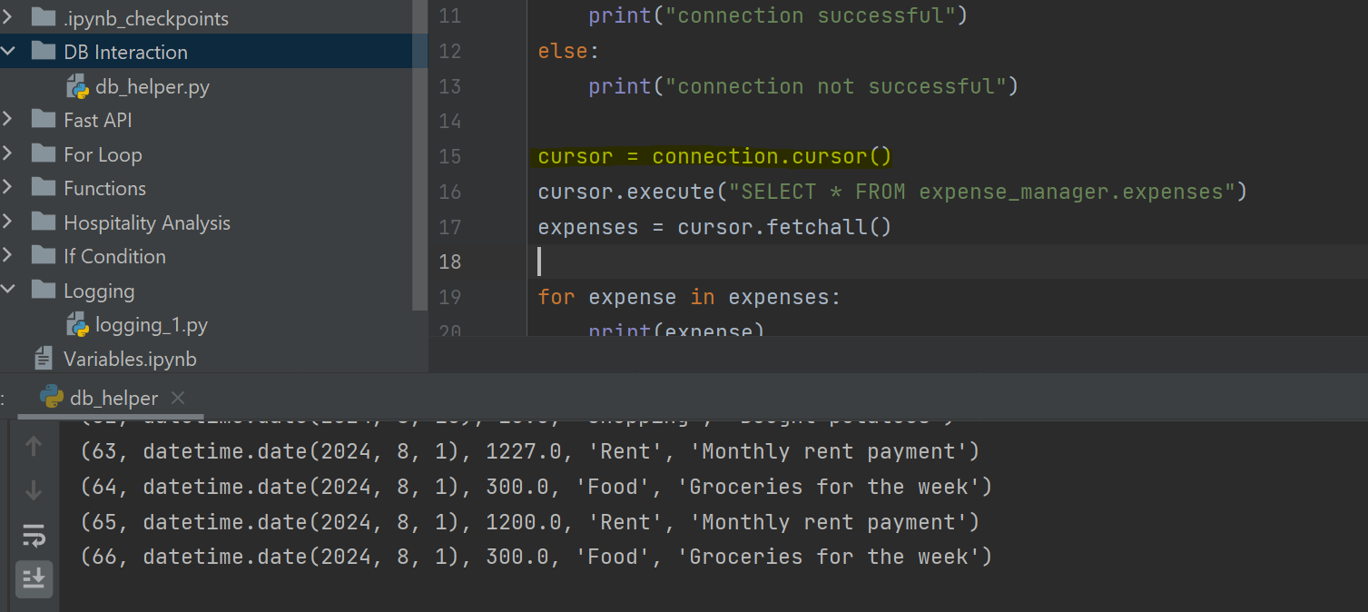

Retrieval as dictionary

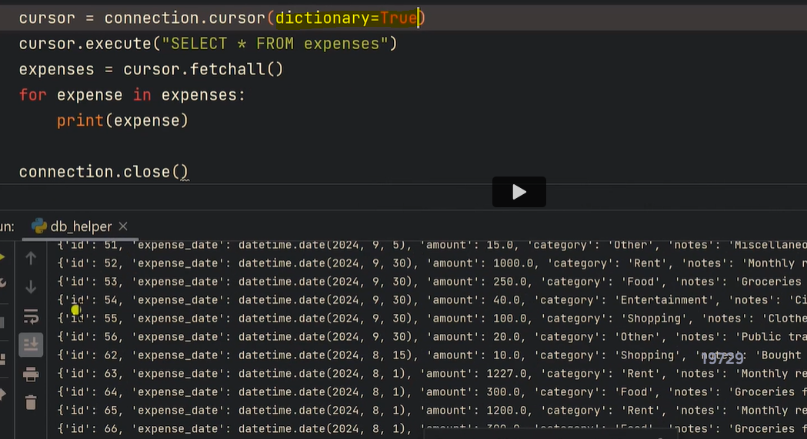

**Writing separate function to connection and cursor**

import mysql.connector  
  
def get_db_cursor():  
 connection = mysql.connector.connect(  
 host='localhost',  
 user='root',  
 password='root',  
 database='expense_manager'  
 )  
  
 if connection.is_connected():  
 print("connection successful")  
 else:  
 print("connection not successful")  
  
 cursor = connection.cursor(dictionary=True)  
 return connection, cursor  
  
  
def fetch_all_records():  
 connection, cursor = get_db_cursor()  
 cursor.execute("SELECT * FROM expense_manager.expenses")  
 expenses = cursor.fetchall()  
 for expense in expenses:  
 print(expense)  
   
 cursor.close()  
 connection.close()  
  
  
  
if __name__ == "__main__":  
 fetch_all_records()

**Passing date to a function and executing a query using cursor**

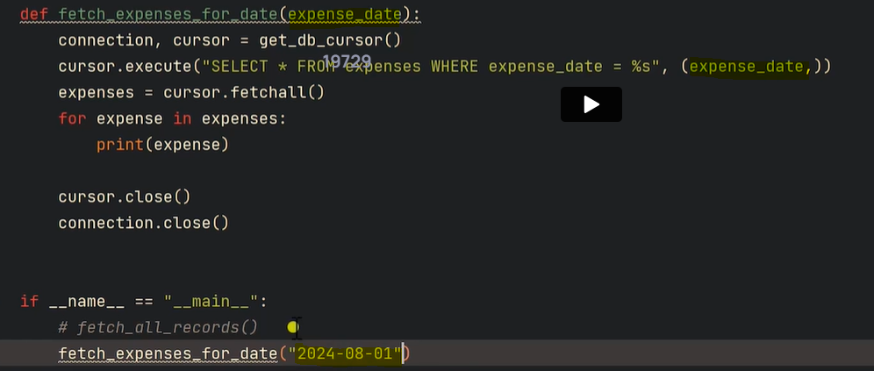

**Some lines in code is getting repeated, to avoid this contextlib is used**

import mysql.connector  
from contextlib import contextmanager  
  
@contextmanager  
def get_db_cursor():  
 connection = mysql.connector.connect(  
 host='localhost',  
 user='root',  
 password='root',  
 database='expense_manager'  
 )  
  
 if connection.is_connected():  
 print("connection successful")  
 else:  
 print("connection not successful")  
  
 cursor = connection.cursor(dictionary=True)  
 yield cursor  
 cursor. close()  
 connection.close()  
  
  
def fetch_all_records():  
 with get_db_cursor() as cursor:  
 cursor.execute("SELECT * FROM expense_manager.expenses")  
 expenses = cursor.fetchall()  
 for expense in expenses:  
 print(expense)  
  
  
def fetch_all_records_date(expense_date):  
 with get_db_cursor() as cursor:  
 cursor.execute("SELECT * FROM expense_manager.expenses where expense_date=%s",(expense_date,))  
 expenses = cursor.fetchall()  
 for expense in expenses:  
 print(expense)  
  
  
if __name__ == "__main__":  
 fetch_all_records_date('2024-08-01')

**Inserting the values in table**

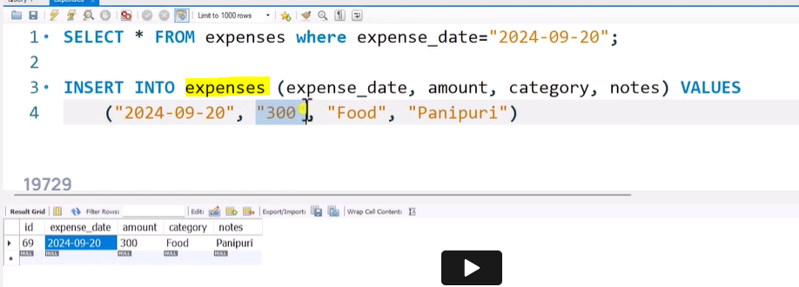

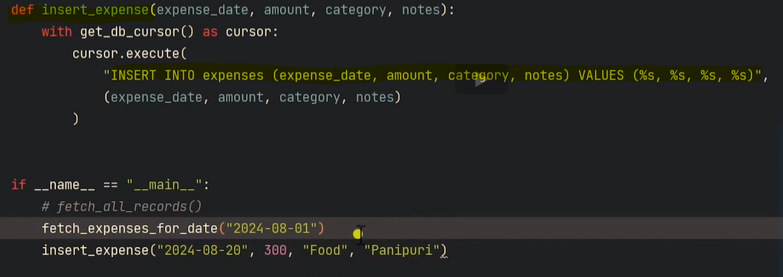

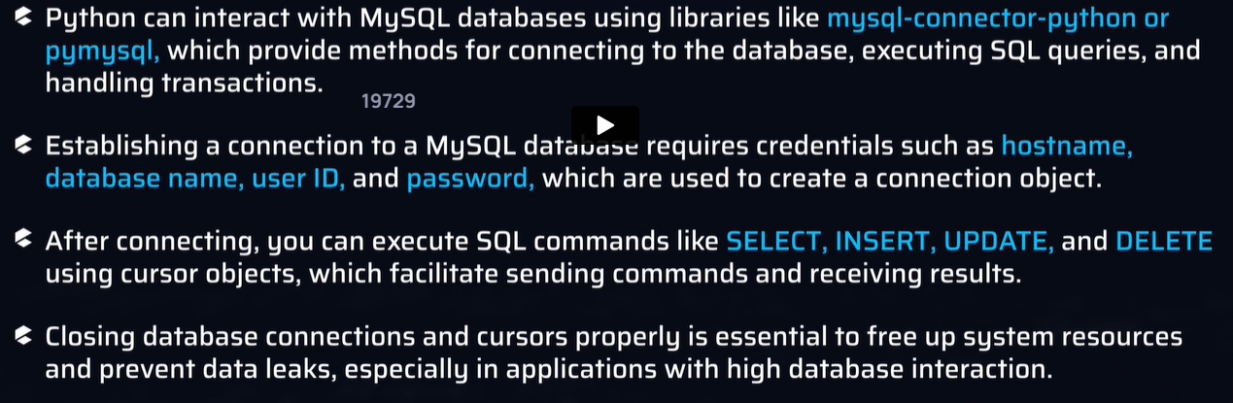

Data validation with Pydantic

Used during FastAPI server development

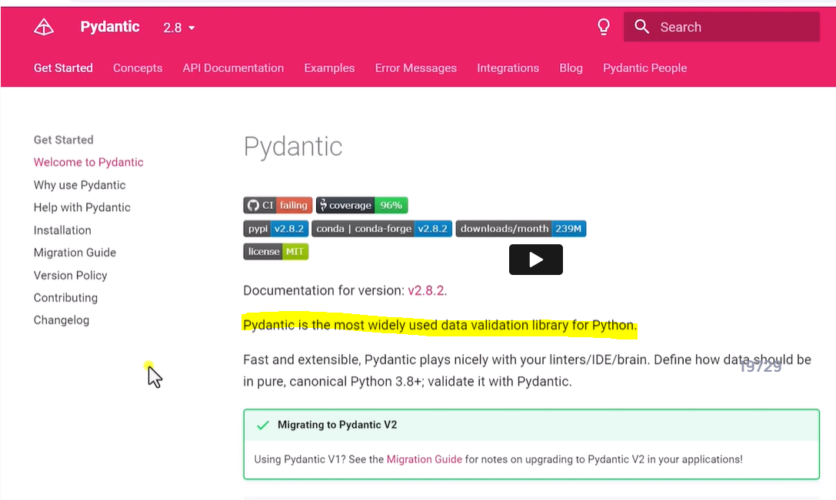

**Defining data types using BaseModel from pydantic**

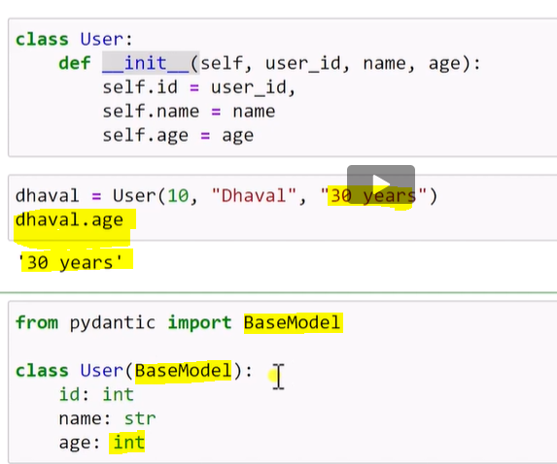

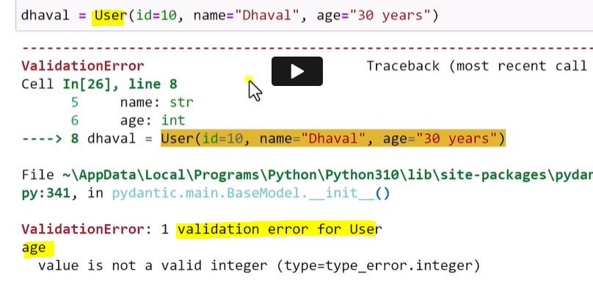

**Optional identifier**

